Cybersecurity Internship – Week 1 Documentation
Security Improvements Implemented
1. Input Validation
The validator library was used to validate user email input during login and registration.
2. Password Hashing
Weak MD5 hashing was replaced with secure bcrypt hashing for better password protection.
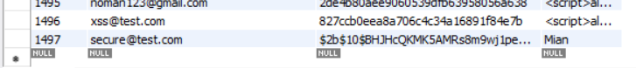
3. JWT Authentication
JWT token-based authentication was implemented after successful login.
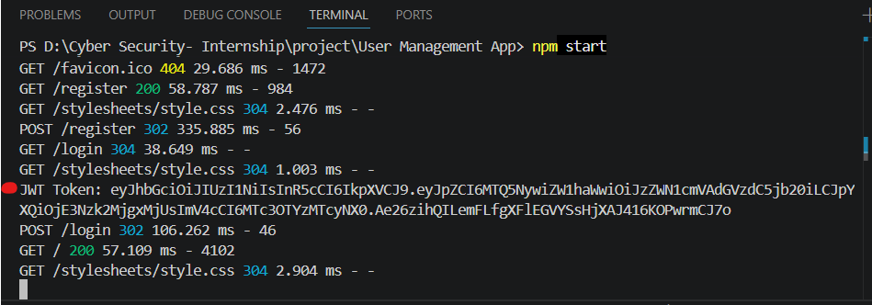
4. Helmet.js
Helmet middleware was added to improve HTTP security headers and reduce vulnerabilities.
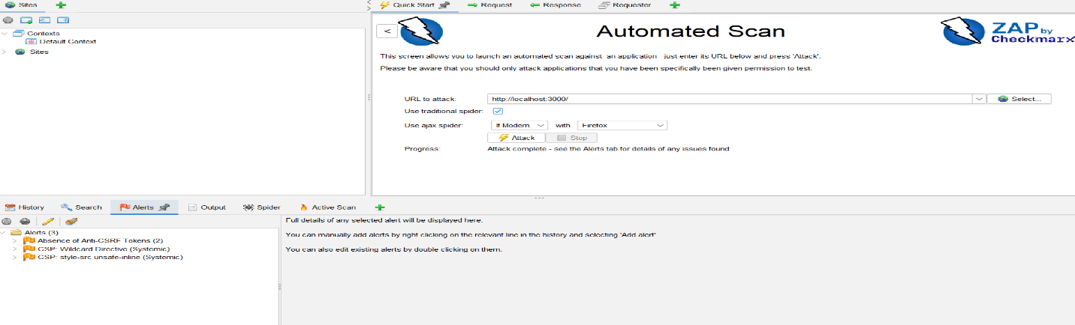
Testing Performed
- Invalid email testing using validator
- bcrypt password hash verification in database
- JWT token generation testing
- OWASP ZAP re-scan after security fixes
Results
- Passwords are now securely stored using bcrypt.
- Invalid email inputs are blocked.
- JWT authentication working successfully.
- OWASP ZAP showed significant reduction in security header vulnerabilities.

